1. Find the domain of each of the following functions:
   1. f(x) = $\sqrt{x^{2}-1}$
   2. f(x) = $\frac{x-3}{x+3}$
   3. f(x) = $\sqrt{-x}$
   4. f(x) = $\sqrt{x}$
   5. f(x) = $\sqrt{{6-x-x}^{2}}$
   6. f(x) = tan(5x)
   7. f(x) = x2 – 4x + 4
   8. f(x) = x2 − 2x + 5
   9. f(x) =
   10. f(x) = $\sqrt{1-2x}$
   11. f(x) = $\sqrt{x^{2}-4x+4}$
   12. f(x) = $\sqrt{x^{2}-6x+7}$
   13. f(x) = $\frac{1}{\sqrt{x^{2}-8x+15}}$
   14. f(x) = $\sqrt{x(x-4)}$

1. Find the range of each of the following functions:
   1. f(x) = x4
   2. f(x) =
   3. f(x) = x2 for 2 < x < 4
   4. f(x) = 3(x + 5)2 + 2
   5. f(x) = cot(2x)
   6. f(x) = x2 − 2x + 5
   7. f(x) = x2 – 4x + 4
   8. f(x) = x2 + 4
   9. f(x) = 2(x2 + 5)
   10. f(x) = (x – 1)2 + 6
   11. f(x) = -x2 + 3x – 2
2. Define following terms with example:
   1. Exponential function
   2. Logarithmic function
   3. Polynomial function
   4. Linear function
   5. Rational function
3. Sketch the graph of following functions:
   1. y =
   2. y=x2 on [2, 8]
   3. 2x + 3y = 6
   4. y = sin(2x)
   5. y = cot(3x)
   6. y = x3
   7. y =√x
   8. y =√x – 5
4. Determine whether the given function is odd, even or neither.
   1. f(x) = x-5
   2. f(x) = x2 + 1
   3. f(x) = x2 + x
   4. f(x) = x4 + 3x2 – 1
   5. f(x) =
   6. f(x) = cosx
   7. f(x) = sinx
   8. f(x) = |x3|
5. Find the Domain and Range of the following graphs:

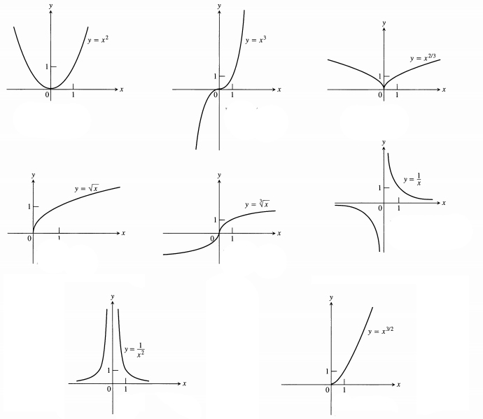

1. Evaluate the limits:

$\lim_{x→1}{(6x^{3}-5x+3})$

$\lim_{x→2}{ \frac{x^{2}-5x+3}{x^{2}-x-2}}$

$\lim_{h→0}$ $\frac{1}{\sqrt{x+h}}-\frac{1}{\sqrt{x}} , x>0$

$\lim_{x→a}$ $\frac{x^{5}-a^{5}}{x^{4}-a^{4}}$